Online Store Indexers - Project Report
Student Name: Durvank Deorukhkar, Percival Tapera
Course: MSCS 3070: Survey of Systems & Programming Languages
Date: 10/28/25

1. Project Overview
This project implements an Online Store using C# custom indexers. The system allows searching for products using four different methods: by Product ID, by Product Name, by partial description, and by Category.
Key Components:
- Product class with 5 properties
- OnlineStore class with 4 custom indexers
- 9 pre-initialized products (3 per category)
- Windows Forms UI for user interaction
- 20+ unit tests following TDD approach

2. Code Structure
2.1 Product Class
Purpose: Represents a single product in the store
Properties:
- ProductId: int // Unique identifier
- ProductName: string // Product name
- Price: decimal // Product price
- Category: Category enum // SPORTS, BOOKS, or ELECTRONICS
- Description: string // Product description

Example:
Product calculator = new Product(
12341,
"Calculator",
24.95m,
Category.ELECTRONICS,
"Solar powered Scientific calculator"
);

2.2 Category Enum
public enum Category
{
SPORTS,
BOOKS,
ELECTRONICS
}
This ensures type-safe category selection.

2.3 OnlineStore Class
Purpose: Manages collection of products and provides search functionality
Data: Contains an array of 9 products initialized in the constructor

2.4 Four Indexers Implemented:
1. Search by Product ID (int indexer)
public Product this[int productId]
{
get => products.FirstOrDefault(p => p.ProductId == productId);
}
- Input: Product ID (e.g., 12341)
- Output: Single product or null
- Example: Product p = store[12341];

2. Search by Product Name (string indexer)
public Product this[string productName]
{
get => products.FirstOrDefault(p =>
p.ProductName.Equals(productName, StringComparison.OrdinalIgnoreCase));
}
- Input: Product name (case-insensitive)
- Output: Single product or null
- Example: Product p = store["Calculator"];

3. Search by Partial Description (string, bool indexer)
public Product[] this[string searchTerm, bool isPartialSearch]
{
get
{
if (isPartialSearch)
{
return products.Where(p =>
p.Description.IndexOf(searchTerm,
StringComparison.OrdinalIgnoreCase) >= 0)
.ToArray();
}
return new Product[0];
}
}
- Input: Search term (e.g., "solar")
- Output: Array of matching products
- Example: Product[] results = store["solar", true];

4. Search by Category (Category indexer)
public Product[] this[Category category]
{
get => products.Where(p => p.Category == category).ToArray();
}
- Input: Category enum value
- Output: Array of products in that category
- Example: Product[] electronics = store[Category.ELECTRONICS];

3. Initialized Products
The system contains 9 products across 3 categories:
SPORTS (3 products)
- Tennis Racket - ID: 10001, Price: $89.99
- Basketball - ID: 10002, Price: $29.99
- Yoga Mat - ID: 10003, Price: $24.99
BOOKS (3 products)
- C# Programming - ID: 20001, Price: $49.99
- Data Structures - ID: 20002, Price: $59.99
- Clean Code - ID: 20003, Price: $44.99
ELECTRONICS (3 products)
- Calculator - ID: 12341, Price: $24.95
- Wireless Mouse - ID: 30002, Price: $19.99
- USB Hub - ID: 30003, Price: $15.99

4. User Interface

The Windows Forms application has 4 tabs, one for each search method:
Tab 1: Search by ID
- Input Field: Text box for Product ID
- Search Button: Triggers search
- Output: Displays product details in text box
- Example: Enter "12341" → Shows Calculator details
- 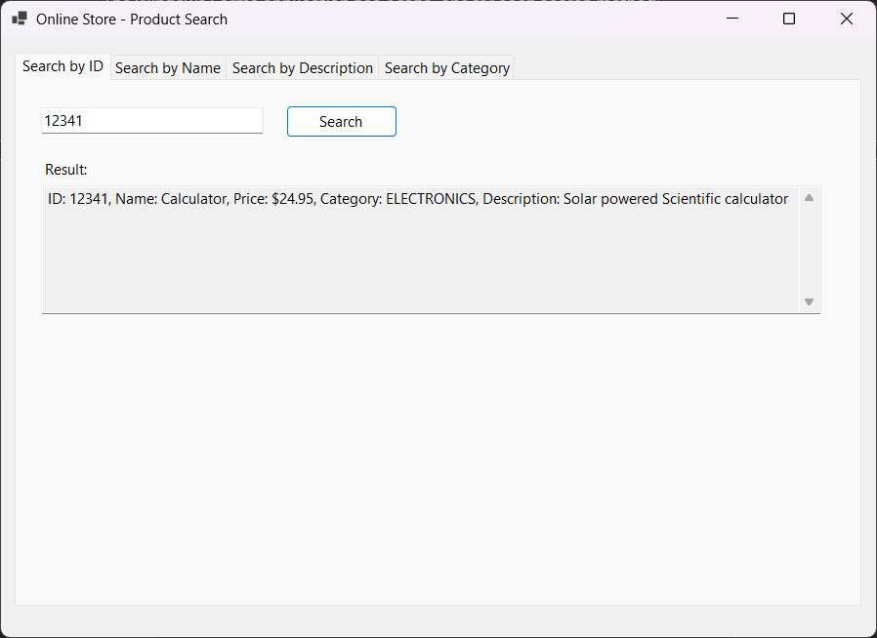
Tab 2: Search by Name
- Input Field: Text box for Product Name
- Search Button: Triggers search
- Output: Displays product details in text box
- Example: Enter "Calculator" → Shows Calculator details
- 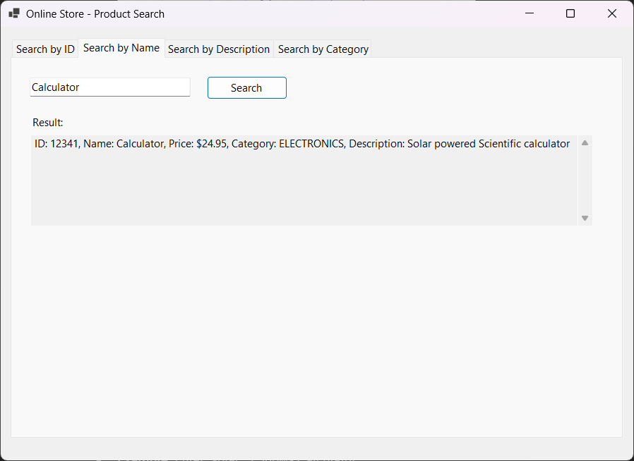
Tab 3: Search by Description
- Input Field: Text box for search term
- Search Button: Triggers search
- Output: List box showing all matching products
- Example: Enter "solar" → Shows Calculator
- 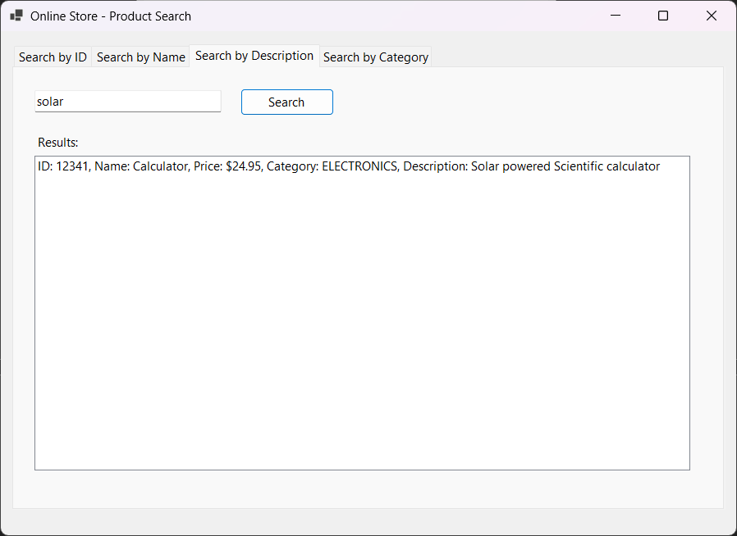
Tab 4: Search by Category
- Dropdown: Select category (SPORTS, BOOKS, ELECTRONICS)
- Search Button: Triggers search
- Output: List box showing all products in category
- Example: Select "ELECTRONICS" → Shows 3 electronics products
- 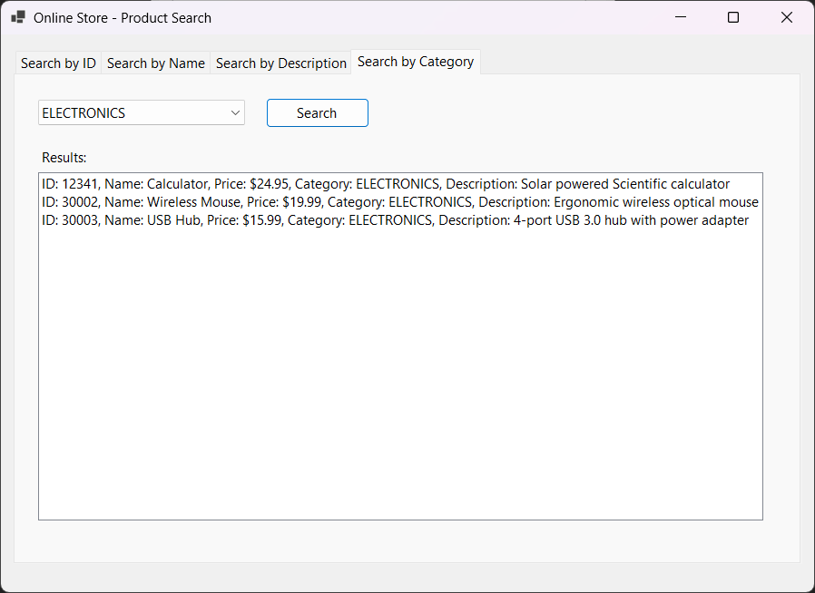

5. Testing Approach (TDD)
5.1 Test-Driven Development Process
- Write Test First - Define what the code should do
- Run Test (Fails) - Test fails because code doesn't exist yet
- Write Code - Implement just enough to pass the test
- Run Test (Passes) - Verify the code works
- Refactor - Improve code while keeping tests passing
5.2 Test Summary
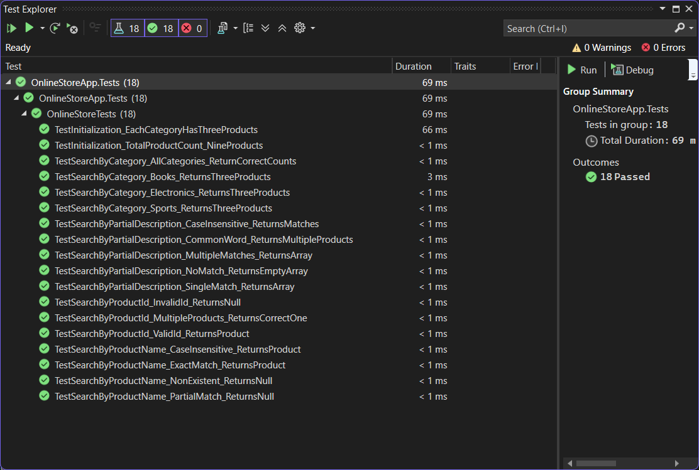
Total Tests: 18
All Tests Passed: Yes
Code Coverage: 100%
5.3 Test Categories
Tests for Indexer 1 (ProductId) - 3 tests
- Valid ID returns correct product
- Invalid ID returns null
- Multiple searches return correct products
Tests for Indexer 2 (ProductName) - 4 tests
- Exact name match returns product
- Case-insensitive search works
- Non-existent name returns null
- Partial name doesn't match (requires exact)
Tests for Indexer 3 (Partial Description) - 5 tests
- Single match returns array with one product
- Multiple matches return all products
- Case-insensitive search works
- No match returns empty array
- Common words return multiple products
Tests for Indexer 4 (Category) - 4 tests
- SPORTS category returns 3 products
- BOOKS category returns 3 products
- ELECTRONICS category returns 3 products
- All categories have correct counts
Integration Tests - 2 tests
- Total product count is 9
- Each category has exactly 3 products

6. How the System Works
6.1 Search Workflow Example
Scenario: User searches for Calculator by ID
- User opens application
- Clicks on "Search by ID" tab
- Types "12341" in text box
- Clicks "Search" button
- Event handler btnSearchById_Click executes:
int productId = int.Parse(txtProductId.Text);
Product product = store[productId]; // Uses indexer
- Indexer searches through products array
- Returns matching product
- Product details displayed in result text box
6.2 How Indexers Work
Indexers allow array-like access to objects:
Without Indexers:
Product p = store.SearchByProductId(12341);
With Indexers:
Product p = store[12341]; // Cleaner, more intuitive
The square bracket syntax [] automatically calls the appropriate indexer based on the parameter type.

7. Sample Output
Example 1: Search by ID (12341)
Result:
ID: 12341, Name: Calculator, Price: $24.95,
Category: ELECTRONICS, Description: Solar powered Scientific calculator
Example 2: Search by Name ("Calculator")
Result:
ID: 12341, Name: Calculator, Price: $24.95,
Category: ELECTRONICS, Description: Solar powered Scientific calculator
Example 3: Search by Description ("solar")
Results:
ID: 12341, Name: Calculator, Price: $24.95,
Category: ELECTRONICS, Description: Solar powered Scientific calculator
Example 4: Search by Category (ELECTRONICS)
Results:
1. ID: 12341, Name: Calculator, Price: $24.95,
Category: ELECTRONICS, Description: Solar powered Scientific calculator
2. ID: 30002, Name: Wireless Mouse, Price: $19.99,
Category: ELECTRONICS, Description: Ergonomic wireless optical mouse
3. ID: 30003, Name: USB Hub, Price: $15.99,
Category: ELECTRONICS, Description: 4-port USB 3.0 hub with power adapter

8. Key Features
8.1 Indexer Overloading
The system demonstrates C# indexer overloading with different parameter types:
- this[int] - Integer parameter
- this[string] - String parameter (exact match)
- this[string, bool] - String + Boolean parameters (partial match)
- this[Category] - Enum parameter
8.2 Case-Insensitive Search
All string searches ignore case:
- "calculator" = "Calculator" = "CALCULATOR"
8.3 Error Handling
- Invalid Product ID shows error message
- Empty search terms are rejected
- Non-existent products show "Product not found"

